PLYMOUTH, CONNECTICUT TRAVELING EXHIBIT OF FLAGS FROM THE COLONIAL AND REVOLUTIONARY PERIOD

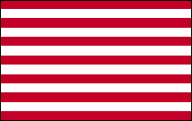
SONS OF LIBERTY, 1765
The original nine stripes of this flag represented the nine colonies that convened the “Stamp Act Congress” in 1765. After repeal of the Act in 1766, the flag became associated with the Sons of Liberty and became known to the British as the “Rebellious Stripes.” The Sons reached their zenith of influence with the Boston Tea Party on December 16, 1773, after which the nine colonies were joined by the rest.
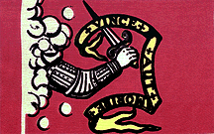

BEDFORD
The original of this flag is in the town library in Bedford, Massachusetts. Tradition has it that it was carried by Bedford Minuteman Nathaniel Page at the battle of Concord. The Latin motto “VINCE AUT MORITE” may be translated into English as “CONQUER OR DIE” or as “VICTORY OR ELSE DEATH”.
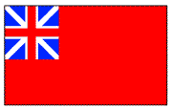

RED ENSIGN, 1770
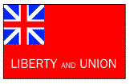
Also called the Meteor flag, this British maritime flag (ensign) was carried on Navy warships throughout the colonial period. It is also the first national flag of the United States.

TAUNTON, 1774 The Sons of Liberty were in the habit of meeting under a large tree (most village greens had one), which was called the “Liberty Tree”. In cities or towns that lacked a tree big enough, the rebels would erect a tall pole as a symbolic tree. This flag was raised on one such “Liberty Pole” in Taunton, Massachusetts on October 21, 1774.
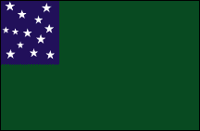

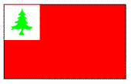
GREEN MOUNTAIN FLAG, 1775 The Green Mountain boys were a militia formed to protect land that the New York Governor corruptly sought to sell out from under Vermonters. When war broke out against the King, they were ready to jump in. On May 10, 1775, Ethan Allen and his “Green Mountain Boys” of Vermont captured Fort Ticonderoga without firing a shot. They also fought with General Stark at Bennington in 1777. This flag is sometimes called the “Vermont Flag”, as Vermont became a Republic after the war and didn’t join the Union until much later

CONTINENTAL, 1775 Believed to have been carried at Bunker Hill, this is a blending of the Meteor flag and the Pine Tree flag. Sometimes referred to as the New England Battle Flag.
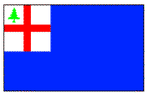

BUNKER HILL, 1775 On the morning of June 17, 1775, as the British advanced up Breeds’ Hill (forever after to be confused with nearby Bunker Hill) in the early morning light they saw this flag above the American fortifications.


WASHINGTON SQUADRON, 1775 George Washington owned his own private navy. Six schooners, to be exact, outfitted at his personal expense in the autumn of 1775. Ever the diplomat, Virginian Washington chose the New England pine tree motif as a gesture of solidarity and friendship between the northern and southern colonies.

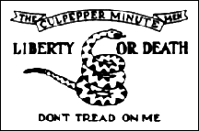
CULPEPPER, 1775 One of the companies in Patrick Henry’s First Virginia Regiment, the Culpepper Minutemen under Colonel Stevens were a fierce-looking group of backwoodsmen who wore “Liberty or Death” emblazoned in white on their green hunting frocks. They preferred rifles to muskets, and went into battle with tomahawks and scalping knives.
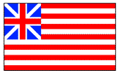

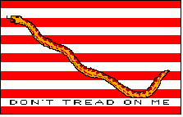
GRAND UNION, 1775 Combining the Meteor flag with the Sons of Liberty flag, this was first raised at sea on December 3, 1775 by John Paul Jones; and on land on January 1, 1776, on Prospect Hill (then called Mount Pisgah) in Somerville, Massachusetts, when the Continental Army was mustered into formal existence. It received its’ name from a reference as the “Grand Union Flag” in one of George Washington’s letters. Curiously, this flag was never officially sanctioned by the Continental Congress. Flying aboard a patriot ship, it received the first foreign salute to an American flag from Governor De Graaff of St. Eustatius Island on November 16, 1776.

FIRST NAVY JACK, 1776
The earliest of the national “rattlesnake flags”, this one flew over the Navy’s first ship, the ALFRED, in January, 1776.

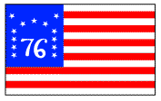

MOULTRIE, 1776 Named for Colonel William Moultrie, this flag flew over Sullivan Island in Charleston Harbor during the battle on June 28, 1776. Sergeant William Jasper risked life and limb several times to replace the flag after it was shot down, inspiring the Americans by his heroism. The British were beaten so badly they didn’t renew the war in the south again until 1778. Look for a crescent moon the next time you see the present day state flag of South Carolina.

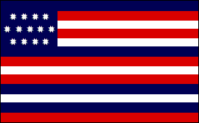
BENNINGTON, 1777 On August 16, 1777, at Bennington, Vermont, General John Stark defeated a large raiding force sent by Burgoyne to capture American supplies stored there. This presaged the great British defeat at Saratoga. Note that this is the only American flag to begin with a white stripe. The original may be seen in the museum in Bennington.
SERAPIS, 1779 Ben Franklin wrote the King of Naples in 1778, describing the new American flag as “Having thirteen stripes alternating red, white and blue.” In August of 1779, the epic naval battle between the Bonhomme Richard (named for Franklin) and the Serapis took place. When John Paul Jones sailed the battered Serapis into the allied Dutch port of Texel, she was flying this flag.

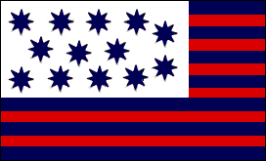
GUILDFORD COURTHOUSE, 1781 One of the bloodiest battles of the war occurred March 15, 1781 at Guilford Courthouse, North Carolina. Under American General Greene, the British inland advance was hurled back to the seacoast by the American militia units, with the British losing a quarter of their troops.
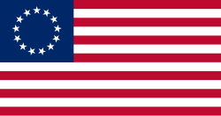
BETSY ROSS, 177 The so-called Betsy Ross flag is an early design for the flag of the United States, which is conformant to the Flag Act of 1777 and has red stripes outermost and stars arranged in a circle. These details elaborate on the 1777 act, passed early in the American Revolutionary War, which specified 13 alternating red and white horizontal stripes and 13 white stars in a blue canton. Its name stems from the story, once widely believed, that shortly after the 1777 act, upholsterer and flag maker Betsy Ross produced a flag of this design.
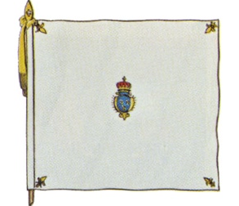
The Rochambeau Headquarters flag, during the American Revolution, was the French Royal Standard flag. This flag was white, with fleur-de-lis in the corners and the royal arms in the center according to Sons of the Revolution Virginia. It symbolized the French King's authority and was flown by the French Expeditionary Force led by Comte de Rochambeau. The flag was flown over the headquarters of Rochambeau, who marched through Plymouth, Connecticut.

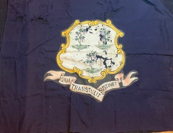
CONNECTICUT STATE FLAG, 1711 The design comes from the seal of Saybrook Colony, designed by George Fenwick when it was established in 1639. That seal depicted 15 grapevines and a hand in the upper left corner with a scroll reading "Sustinet qui transtulit". When Connecticut Colony bought Saybrook in 1644, the seal transferred to Connecticut Colony. On October 25, 1711, the governor and legislature changed the seal. They reduced the number of grapevines from 15 to three, in order to represent the three oldest settlements (Windsor, Wethersfield, and Hartford)^{[7]} (or possibly the three separate settlements, Connecticut Colony, Saybrook Colony, and New Haven Colony, which had been absorbed into Connecticut by that time) and rearranged the wording and position of the motto.
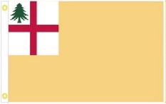
CONNECTICUT MILITIA FLAG

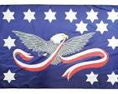
The Whiskey Rebellion (also known as the Whiskey Insurrection) was a violent tax protest in the United States beginning in 1791 and ending in 1794 during the presidency of George Washington. The events contributed to the formation of political parties in the United States, a process already under way. The whiskey tax was repealed in 1802 during the Jefferson administration.

SPONSORS OF THE TRAVELING FLAG EXHIBIT: DelCegno Family, First Congregational Church, Denise Clapsaddle, Plymouth Senior Outreach Group, Keith Golnik (3 flags), Jerry Milne (2 flags), Bill and Anita Hamzy (3 flags), First Baptist Church, Helena, Cathy, Dorine and MJ, Boy Scout Troop 75, Mattatuck Scout Reservation, Harry S. Fisher Elementary School, Eli Terry Jr. Middle School, Plymouth Center School, Terryville High School, Randy Picard, Carol Ferland, Rev. Zachary Mabe/Terryville Congregational Church.

